# 

27 October 2022

Hatim Said

gla data 2

***Assignment 1 Data Visualisation***

Contents

0

Task 1 1

Task 2 3

Task 3 4

# Task 1

There are several legal and moral policies that you as a data analyst are supposed to follow such;

* **data protection act 2018**
* the act provides power and control for individuals of their personal data and to help originations with their lawful processing of personal data.
* **Computer misuse act 1990**
* The act makes it an offence to steal or supply to use unlawfully gaining access to computer material or stopping the operations of a computer
* **Police and justice (computer misuse) act 2006**
* unlawful modification of computer material an offence
* **Copyright, design and patents act 1998**
* Gives a user or creator the legal right copy, adapt, communicate, lend or sell copies of the work
* **The copyright relegation (computer programs) 1992**
* Protects a user right to own a computer literary and design material.
* **Computer right act 2018**
* The act protects the confidentiality, integrity and availability of computer systems, programs and data

# Task 2

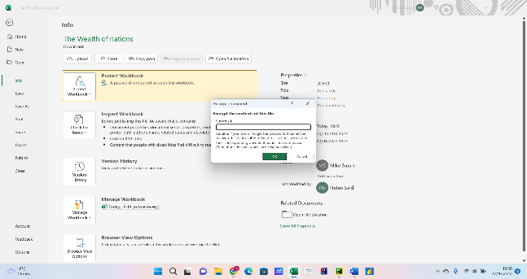 password set for the workbook

changed column c to display British pound currency

using the table I filtered to only show 2019

I was able to create a line graph using three different categories ranking, countries and GDP. The countries and rankings are along the x axis and y axis and label the chart and the two axis so that its readable to anyone, I moved the graph to separate sheet.

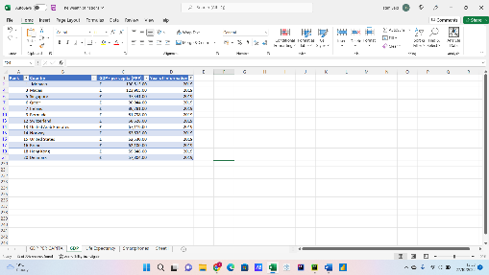 using the filter I lowered the ranking to show only the top 20

placed a graph using only the top 20 into a graph placed underneath the table

Placed print, copy and paste macros

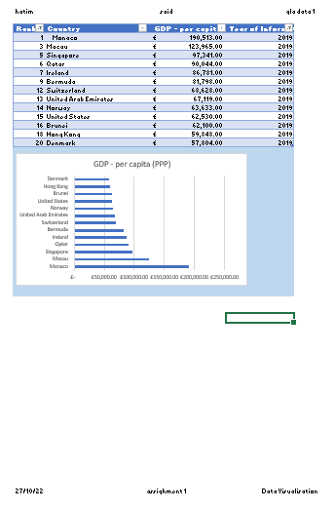

Placed headers and footers

# Task 3

Completed the tableau project with both friendly colour blind pallet and a title for all graphs giving a small description.

[assighment 1 edit | Tableau Public](https://public.tableau.com/app/profile/hatim4710/viz/assighment1edit/Dashboard2)